Browsing the Library
When a user lands on the page, they are presented with the full program catalog in a grid below. Each card in the grid shows the program's cover image, title, expert name, type (Masterclass or Series), duration or episode count, and price.
At the top of the page, filter tabs allow the user to narrow the catalog by programType - which Aditi will provide. Filtering updates the grid immediately and collapses the featured row, showing only the relevant results.
No account is required to browse. Any visitor can scroll through the catalog freely.
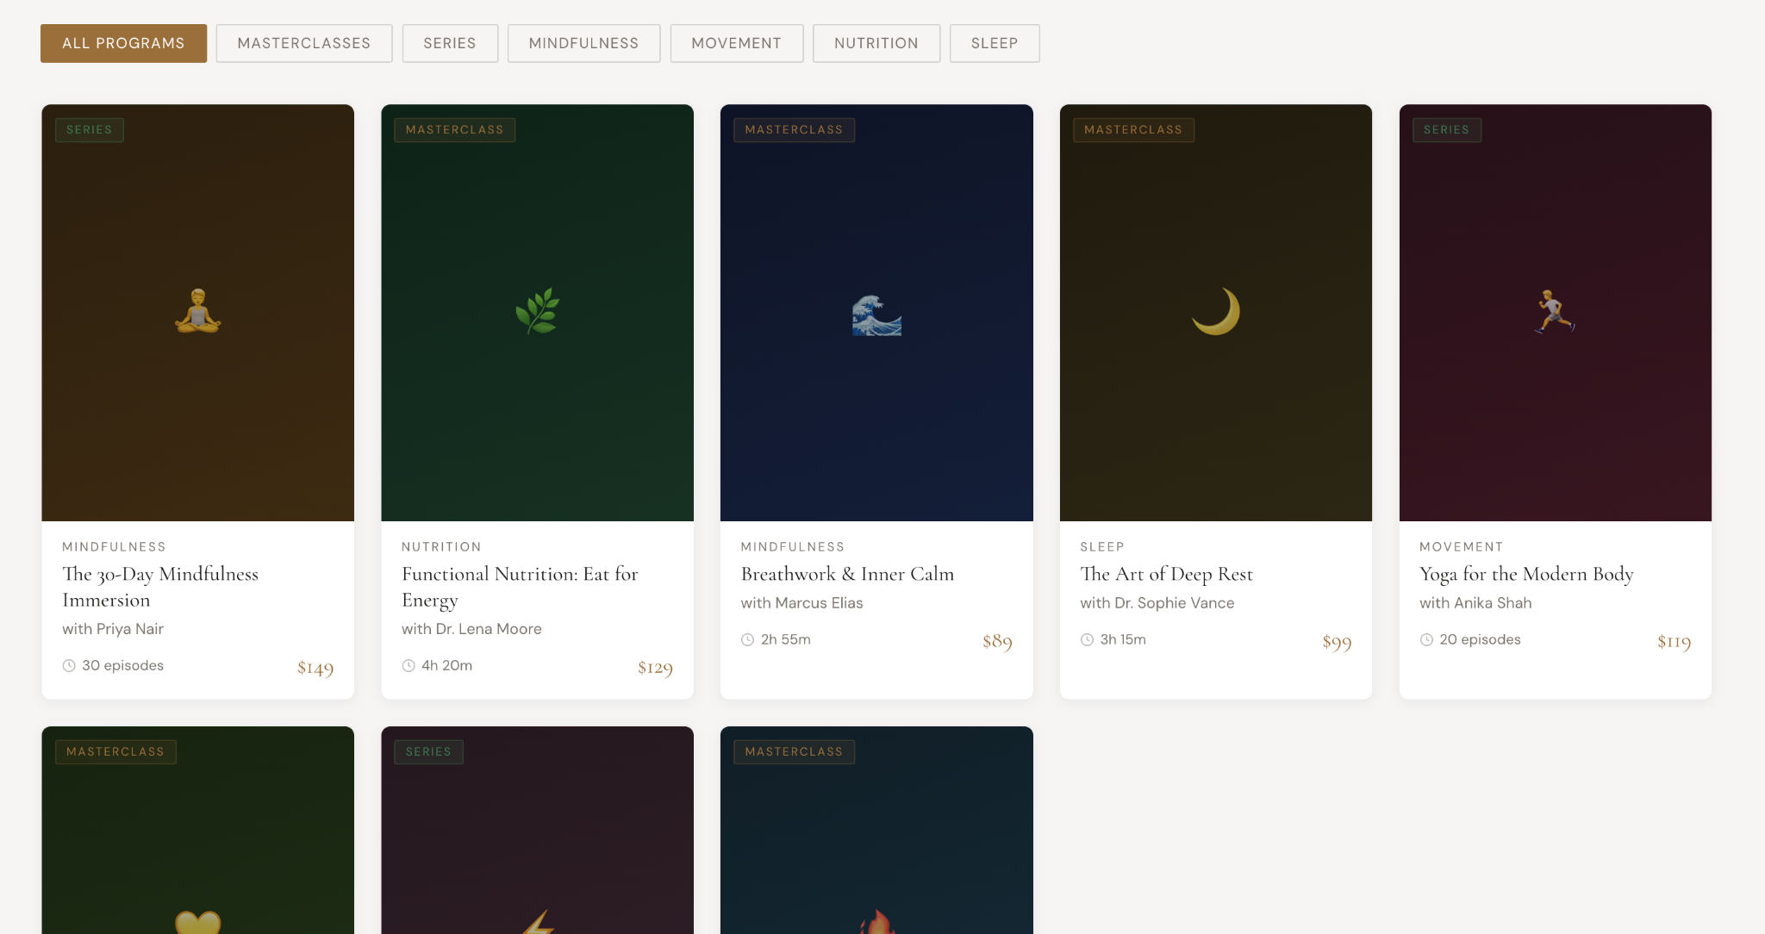

Viewing a Program
When a user clicks on any card, they are taken to the detail page for that item. Here they can see the full item title, expert credentials, descriptive tags, and a brief description of the item.
A trailer is available to watch before purchasing — the user can click the trailer player to preview the program content. - this will be uploaded on youtube. I only need the embed url from the backend.
For Series, a list of episodes is shown with each episode's title, a short description, and its duration. All episodes appear locked at this stage, indicating they are accessible only after purchase.
The page also displays the price clearly, along with a one-time payment notice, and a breakdown of what is included — such as lifetime access, device availability, downloadable resources, and a certificate of completion.
A back button is available at all times to return to the library.
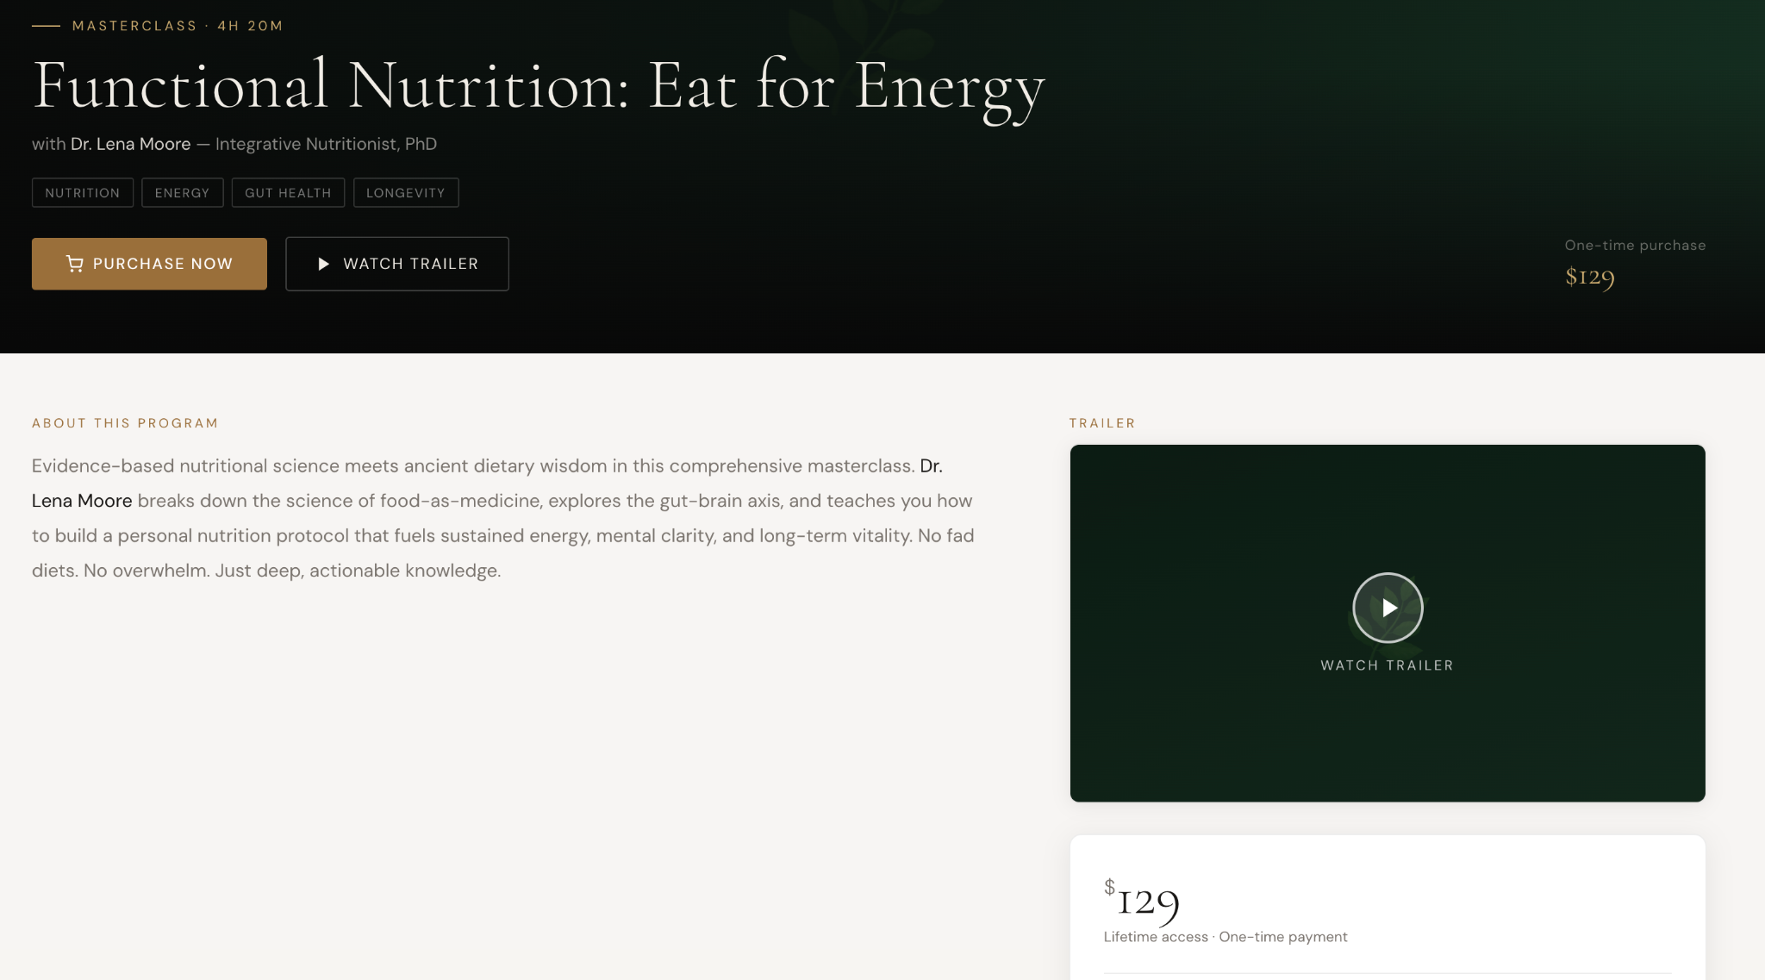
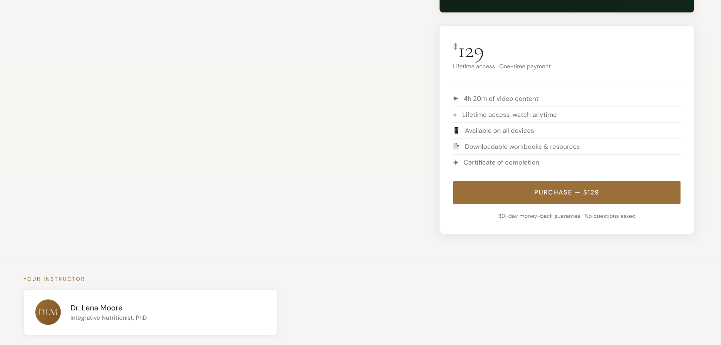

Purchasing a Program
When the user is ready to buy, they click the Purchase button — available both in the hero section of the detail page and inside the purchase card on the right.
If the user is not logged in at this point, they are prompted to sign in or create an account before proceeding. Once authenticated, they are taken through the payment flow. The payment flow will be similar to our program payment flow.
After a successful purchase, the user receives confirmation and the video is added to their personal library in the dashboard. For Series, the episode list unlocks and the user can begin watching any episode in the dashboard.

Post-Purchase Access
Once a program is purchased, the user can return to it at any time through their library. All content — full video for Masterclasses, or individual episodes for Series — is accessible without any time restriction. The user's access is permanent and tied to their account.
All the videos will be uploaded on youtube as unlisted and I will need every video/episode/trailer’s embed url.

How to get embed URL from YT:
- Once the video is uploaded, right click the video and copy the embed code
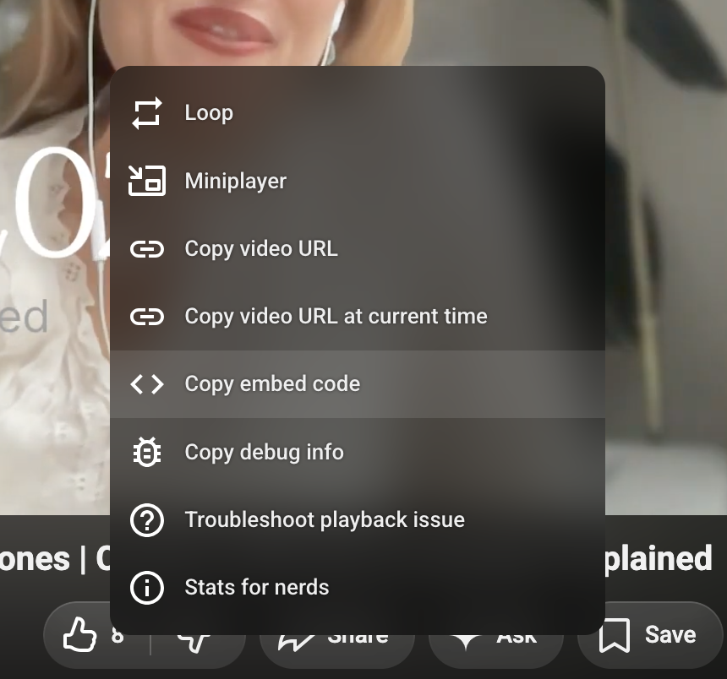

2. It should be something like this:
<iframe width="990" height="557" src="https://www.youtube.com/embed/ZhnA6836TN8" title="How Stress &amp; Sleep Disrupt Women’s Hormones | Cortisol, HPA Axis &amp; Ovulation Explained" frameborder="0" allow="accelerometer; autoplay; clipboard-write; encrypted-media; gyroscope; picture-in-picture; web-share" referrerpolicy="strict-origin-when-cross-origin" allowfullscreen></iframe>

What I need is the src field value. This is something Aditi will have to do when she creates a full google sheet of data.

